Unit 3 – More Forms

In this lesson, we will be looking at more input types that can be added to a jQuery Mobile form to allow for more user input.

Open the MoreFormsDemo.html file and notice that we are looking at a form that accepts patient information. As of now, we have a first name, last name, and a gender input. However, we want to increase the amount of information asked for in the form. The first thing we want to add is patient birthday. We could add a simple text box for user input, but we can do better than that. In this case, we want to add a calendar selection widget so the user can click on an actual date on a calendar. This functionality is not included in the default jQuery Mobile libraries we have been using in our head. So, notice that we now have these three new links to give us the functionality we need.

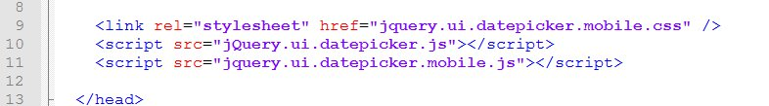

Because we have access to these new resources, we can now add a new input for birthday. So, let’s add a new paragraph tag between the last name and gender slider for our new input. Then, add a label so the user knows what type of info is required. Now, add the input type. We use the type=”date” attribute to indicate that we want the calendar widget.

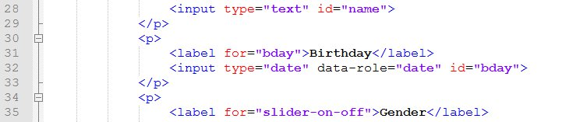

When the program is run, we now see an input for birthday that when clicked on, should produce a calendar.



Next, we want to add an input for patient symptoms. Again, we could just do a simple text box but variety is the spice of life so let’s try something else. Another option for forms in jQuery Mobile are check boxes. Let’s add a new paragraph tag after our gender input and create the set of check boxes shown below. We will start with a legend tag that acts as a label for the entire list of check boxes. Then, have an input and a label for each text box option.

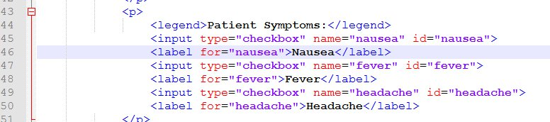

This will give us a nice, expandable, list of check boxes in our form as shown below.

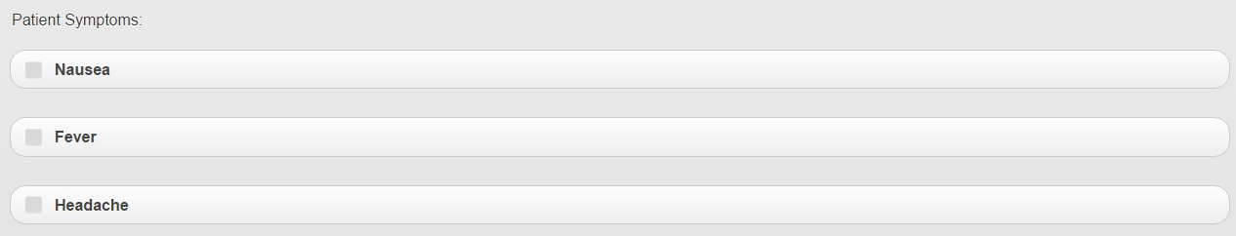

For your assignment, use what you’ve learned and complete the More Forms Assignment on Portal.